**Face Recognition System for Boarding Control at Airport**

##### UDP

A project Report

***Submitted by***

|  |  |
| --- | --- |
| Kartik Fruitwala | 160090107007 |
| Rahul Gandhi | 160090107009 |
| Utsav Haveliwala | 160090107016 |
| Abhishek Jariwala | 160090107018 |
| Yashesh Pandya | 160090107029 |

***Guided by***

###### Prof. Neelam A. Surti

###### Prof. Chetan K. Solanki

*In partial fulfillment for the award of the degree of*

##### Bachelor of engineering

*In*

Department of computer engineering

#### C. K. Pithawalla college of engineering and technology, Surat

Gujarat technological university, Ahmadabad

## Index

1. Index ……………………………………………………………………………………………………...2
2. List of Tables 6
3. List of Figures 7
4. List of symbols, abbreviations and nomenclature 8
5. Introduction 9
   1. Project summary 9
   2. Customer 9
      1. Admin 10

* Staff 10

1. Aim and objective of project 10
2. Problem specification 10
3. Prior art search 11
4. Tools/technology required 12
5. Design 13
6. Design analysis 13
7. Pictorial presentation 13
8. Use-case diagram 14
9. E-R diagram 16
10. Canvas sheet 17
    * + 1. AEIOU Canvas 17
        2. Empathy Canvas 18
        3. Ideation Canvas 19
        4. Product Development Canvas 20
        5. Business model Canvas 21
11. Implementation 24
12. Conclusion 30
13. References 31

We are using this opportunity to express our gratitude to everyone who supported us throughout the course of this project. We are thankful for their aspiring guidance, invariably constructive criticism and friendly advice during the project work. We are sincerely grateful to them for sharing their truthful and illuminating views on a number of issues related to the project.

With immense please, we would like to express a deep sense of gratitude to the Head of the Computer Engineering Department and our faculty guide **Prof. Neelam A. Surti** and our co-guide **Prof. Chetan K. Solanki** for their valuable suggestions and to help us in preparation of project report and presentation. We would also like to thank all those faculties who have contributed to the completion of the project and helped us in the valuable suggestion to make our project and helped us with valuable suggestions for improvement and innovative ideas. They helped us by solving many doubts and suggestions many references.



**C. K. Pithawalla College of Engineering and Technology, Surat**

### Department of Computer Engineering

##### Year – 2020

###### Date:

*This is to certify that the project entitled “***Face Recognition System for Boarding Control at Airport***” has been carried out by following students under my guidance in partial fulfillment of the degree of Bachelor of Engineering in Department of Computer Engineering (8thSemester) of Gujarat Technological University, Ahmadabad during the academic year 2019-20. The work done by them is found satisfactory.*

|  |  |
| --- | --- |
| Kartik Fruitwala | 160090107007 |
| Rahul Gandhi | 160090107009 |
| Utsav Haveliwala | 160090107016 |
| Abhishek Jariwala | 160090107018 |
| Yashesh Pandya | 160090107029 |

|  |  |  |
| --- | --- | --- |
| **Prof. Neelam A.Surti**  **Prof. Chetan K. Solanki**  **Guide** | **Jury** | **Prof. Neelam A Surti**  **Head of Department** |

According to the current scenario, this is analyzed from sources that the conventional method of boarding was very much slow, due to the fact that it is a manual procedure. The challenge in this method is security and another disadvantage are that the boarding pass can be faked.

Therefore, to overcome these drawbacks this system will firstly get the profile of the passengers when the passenger will upload their data at the time of registration. At the time of boarding, the passengers pass through the built-in camera, which clicks their photo and matches it with that of database. The module will fetch the face data from the database which is stored at the time of registration. If the person is legit then he is allowed to board, otherwise not. The passenger may present their unique photo ID proof at time of boarding. Using biometric data, the process can be made smooth and simplified.

Table 1. Patents 2

Table 2. Comparison Table 2

Figure 1. AEIOU Canvas 4

Figure 2. Ideation Canvas 5

Figure 3. Product Development Canvas 6

Figure 4. Empathy Mapping Canvas 7

Figure 5. Passengers Module 9

Figure 6. Ticket Module 9

Figure 7. Design Module 10

Figure 8. Implementation 11

Figure 9. Database Diagram 20

|  |  |
| --- | --- |
| **Symbol** | **Abbreviation** |
| HOD | Head of the department |
| PAS | Priority art search |
| Db | Database |
| FRS | Facial Recognition System |
| SM | System Module |

# Introduction

#### Project summary

#### The main goal of our app is to help passengers from waiting too in queue. Firstly, the passengers have to enter the source and destination place and the basic information about them along with passport id. After this phase, when the passenger wants to travel by flight, at the time of boarding process, they have to pass through the cameras which are attached with the system. Finally, the cameras will capture the photograph of passengers, then the system will match the captured photo with the photo which had been fetched with the help of passport id from the database. If the passenger is recognized then he/she is allowed to board the flight, otherwise not so.

#### 

#### Customer

* The consumer needs to register in order to book a ticket. The system will ask the basic information regarding customer such as email id, phone no etcetera. This information will be stored in the database.
* After the registration phase, the customer is redirected to the login page. This page can be used to authenticate the user to the system. The system checks the entered email id and password with the database and then allows user to surf the website.

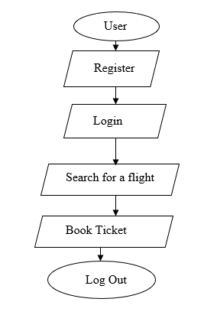

#### Admin

* Admin is the handler of the system. Admin has privileges of adding or removing flight details, managing user profile and database.
* Specifically, admin can handle the customer request, flight information and booking information.

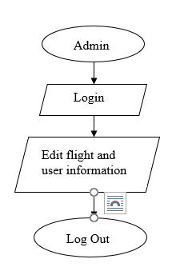

**Aim and objective of project**

* Easier and quicker boarding control
* Time efficient
* User one of the biometric information
* Reduces the queue at the airport
* Automated process
* Easy interface to book flight tickets
* Displays flight information from provided places

#### Problem specification

The system needs to be developed for all the passengers or travelers who uses flight mode for their travelling purpose.

The earlier scenario was:

* In the traditional way, the passengers have to stand in queue for a long period of time. In fact, the process was slower as the user will ask the operator to enter the ticket no. then he will check it in their database and then the boarding pass was generated.
* Hence the customer has to wait for too much time.
* The other problem could be that the boarding pass can be faked.

#### Prior Art Search (PAS):

|  |  |  |  |
| --- | --- | --- | --- |
| **Sr. no.** | **Patent no.** | **Patent name** | **Reference no.** |
| 1 | US5991429A | System for identifying individuals for the purposes of determining clearance access or surveillance | [1] |
| 2 | US20060120571A1 | System for identifying passive face recognition | [2] |
| 3 | US20140016837A1 | Google’s face recognition from different angles | [3] |
| 4 | US8798391B2 | Method for preprocessing an image in facial recognition system | [4] |
| 5 | EP2680190A3 | Facial recognition system for unlocking device with the use of camera, face detection and localization | [5] |
| 6 | US7175528B1 | Passive biometric customer identification and tracking system | [6] |
| 7 | US9639740B2 | Face detection and recognition from the digital image | [7] |
| 8 | US5164992A | A facial recognition system for identifying members of an audience | [8] |

**Tools/technology required**

Following tools and technologies are recommended requirements:

* + **Hardware requirements:**
* A decent camera
* Processor: Pentium iv or higher
* Ram: 4 GB or higher
* Hard disk space: at least 500 KB
  + **Software Requirements:**
* Python
* MySQL
* WAMP/XAMPP Server
* Windows

# Design

As a development of any software we need to design and map design to our final product in form of graphical representation.

#### Design analysis

We made different UML diagrams as well as pictorial presentation to view system from development point of view.

#### 2.1.1 Pictorial presentation

#### Passengers Module

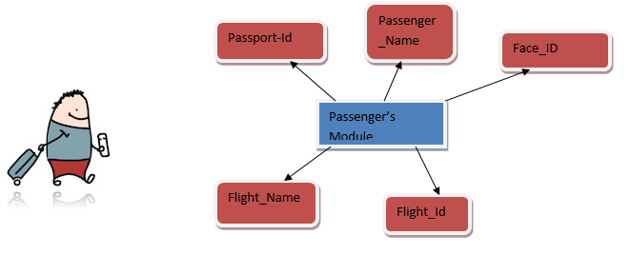

* + 1. **Ticket Module**

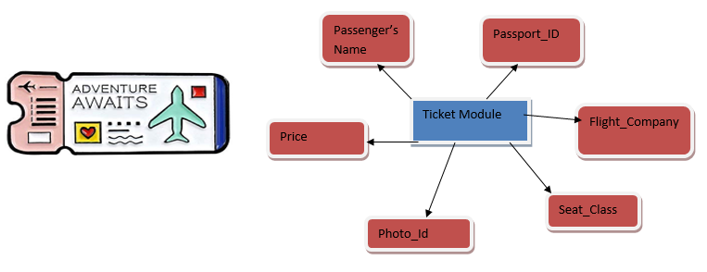

* + 1. **Design Module**

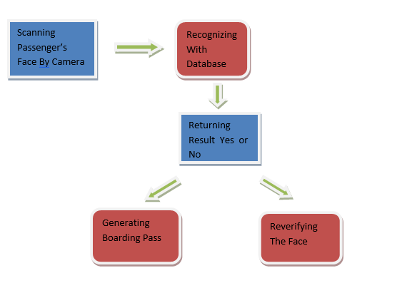

**2.1.2 Use-case diagram**

**Admin**

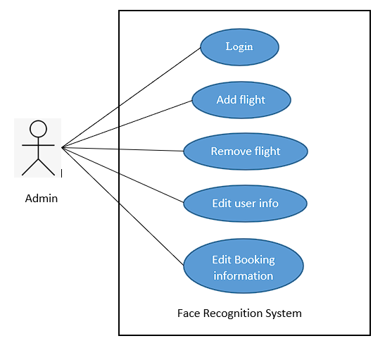

**User**

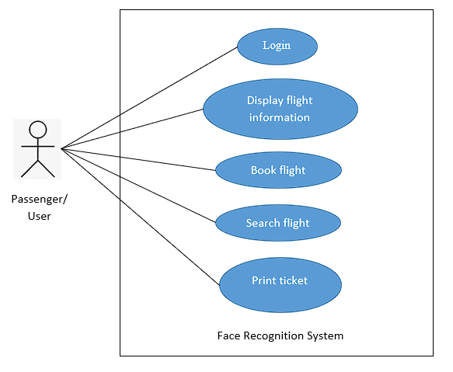

*Figure 2.1.2Use-case diagram*

**2.1.3 E-R diagram**

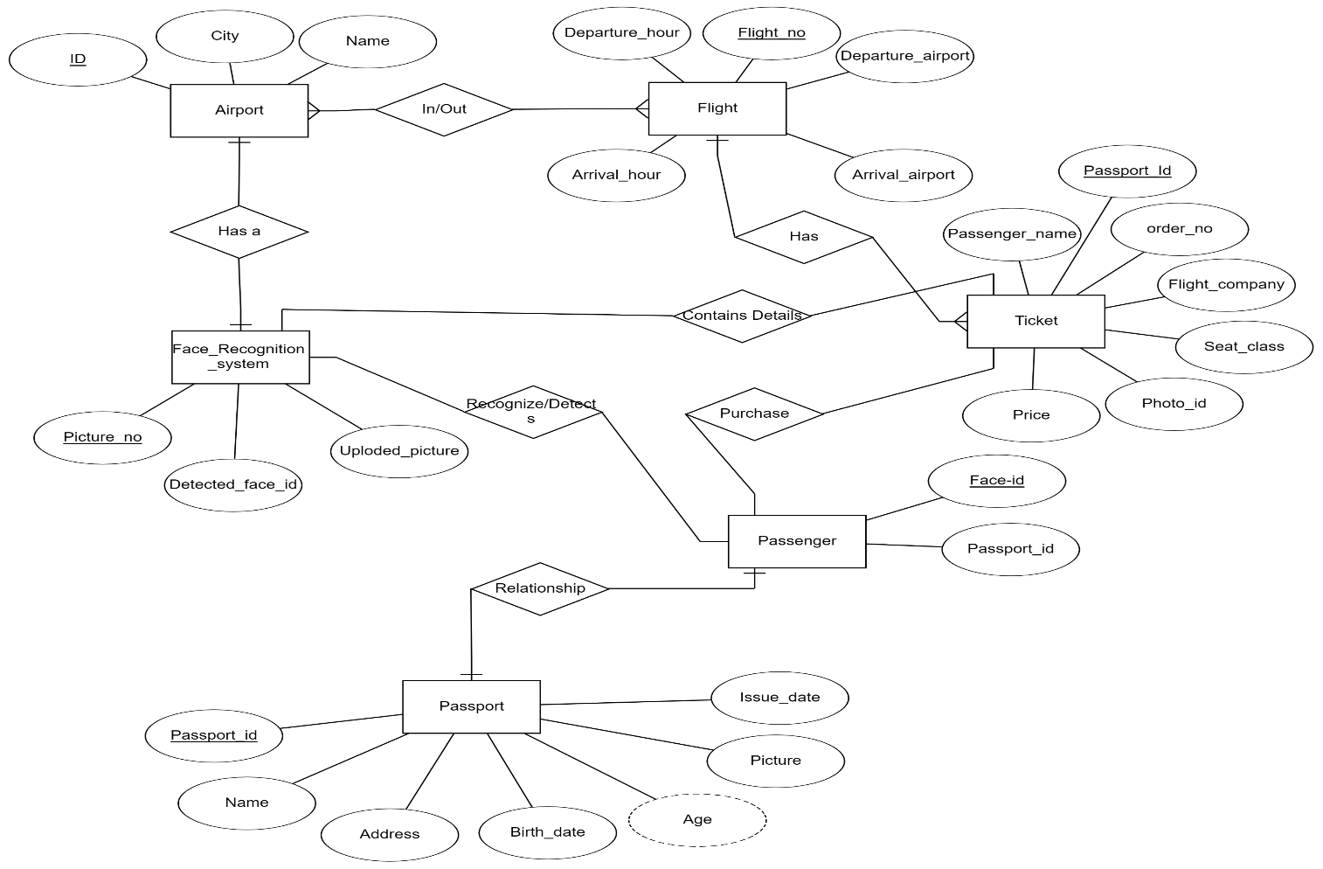

*Figure 2.1.3E-R diagram*

# Canvas sheet

#### AEIOU Canvas

#### 

*Figure 2.2.1 AEIOU summary*

* **Activities:**
* Check-in
* Security Checking
* Luggage Weighting
* Boarding
* Loading of check-in luggage
* Luggage Wrapping
* **Environment:**
* Overcast Weather
* Noisy at boarding area
* Peaceful at terminal passage
* **Interaction:**
* With Police
* With Guards
* With Airport Staff
* With passengers
* **Objects:**
* Computers
* Baggage wrapping machine
* Airplane
* Baggage Weighting Scale
* Conveyer belt
* **Users:**
* Passengers
* Cabin Crew
* Airport Staff

#### Empathy Mapping Canvas

#### 

*Figure 2.2.2Empathy canvas*

* **Users:**
* Passengers
* Cabin Crew
* Airport Staff
* **Stakeholders:**
* Government
* Passengers
* Airlines
* **Activities:**
* Luggage weighting
* Security checking
* Boarding
* Loading of check-in luggage
* Luggage Wrapping
* **Story Boarding:**
  + - 1. **Happy:**

Once, there was a businessman who was getting late to catch his flight. As our system was automated, the businessman was able to catch his flight before departure.

* + - 1. **Happy:**

As our system was using biometric data for storing authorized users’ information, so because of that security is enhanced and the unauthorized user was not able to get into the system.

* + - 1. **Sad:**

As our system was fully automated, it required only one operator to operate the system. Due to which unemployment is introduced.

* + - 1. **Sad:**

Once upon a time, a person was voyaging to another city with a new facial look. Our system failed to recognize the system.

#### Ideation Canvas

#### 

*Figure 2.2.3Ideation canvas*

* **People:**
* Passengers
* Airport staff
* Cabin Crew
* **Activities:**
* Automatic boarding pass generation
* Face Detection
* **Situation/Context/Location:**
* Boarding Control at Airport
* Attendance Filling at School
* Employee Tracking
* **Props/Possible Solution:**
* Computers
* Dot Projectors
* Cameras

#### Product development canvas

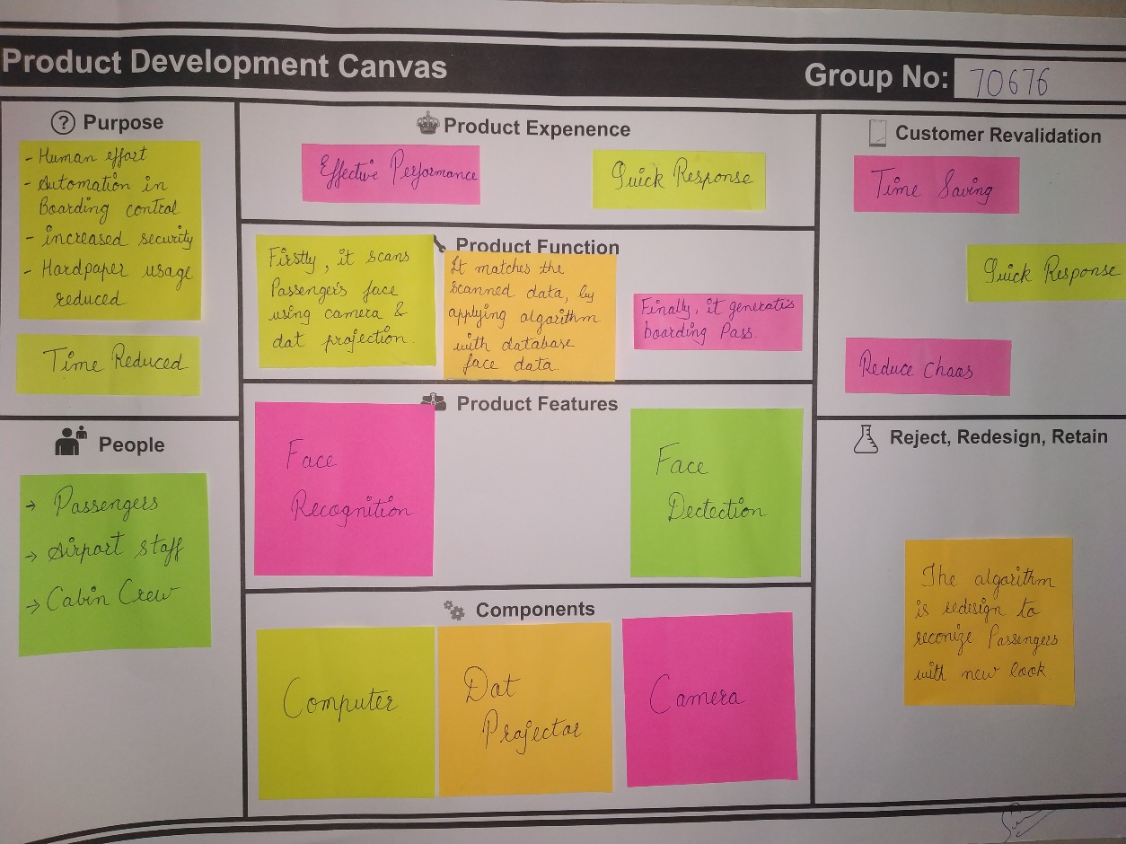

*Figure 2.2.4Product development canvas*

* **Purpose:**
* Reduction in human effort
* Automation in boarding control
* Increased security
* Usage of hard copy of paper reduced
* Time Reduced
* **People:**
* Passengers
* Airport staff
* Cabin crew
* **Product Experience:**
* Efficient performance
* Quick response
* **Product Function:**
* Firstly, it scans passengers face using camera and dot projection.
* Then, it matches the scanned data by applying algorithm with database face data.
* Finally, it generates boarding pass.
* **Product Features:**
* Face Recognition
* Face Detection
* **Components:**
* Camera
* Dot Projector
* Computer
* **Customer Revalidation:**
* Time saving
* Quick Response
* Reduced chaos
* **Reject, Redesign and Retain:**
* The face recognition algorithm is redesigned to recognize the passenger having new facial look.

#### Business Model Canvas

#### 

*Figure 2.2.5 Business Model canvas*

###### Key Partners:

* + Airport
  + Customer
  + Airlines
  + Government
  + Transport Services

###### Key Activities:

* + Registration with biometric data
  + Book flight tickets
  + Recognize face at airport
  + Generate boarding pass

###### Value Proposition:

* + Time saving
  + More accurate
  + Quick response
  + Reduce public chaos
  + Easy monitoring of activity

###### Key Resources:

* Software:
  + Python
  + PyCharm IDE
  + OpenCV
  + Scripting language like php
* Hardware:
  + Server
  + Built-in cameras

###### Customer Relationships:

* + Online FAQs
  + Easy monitoring
  + Automated service
  + 24*7 helpline available

###### Customer Segment:

* + Business to business (B2B)
    - Airports
    - Government
    - Transport agency
    - Security service provider
  + Business to Customer(B2C)
    - General citizens

###### Channels:

* + Through website
  + Campaigning
  + Social media
  + Marketing

###### Cost Structure:

* + Marketing
  + Purchase host and domain name
  + Investment
  + Maintenance
  + Testing
  + Maintenance

###### Revenue Streams:

* + Google Ad sense
  + Service charges
  + Sponsorship
  + Government
  + Commission from the airports

# Implementation

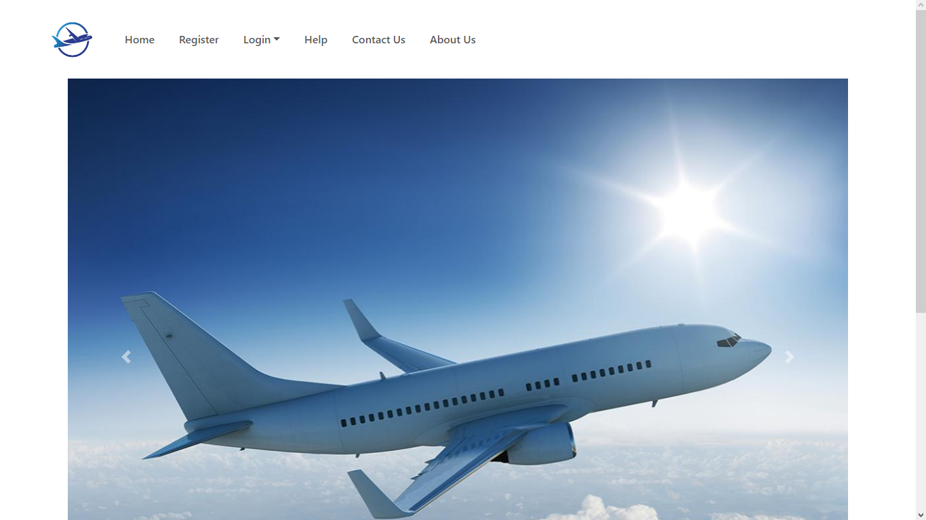

**Interface 1: Home Page**

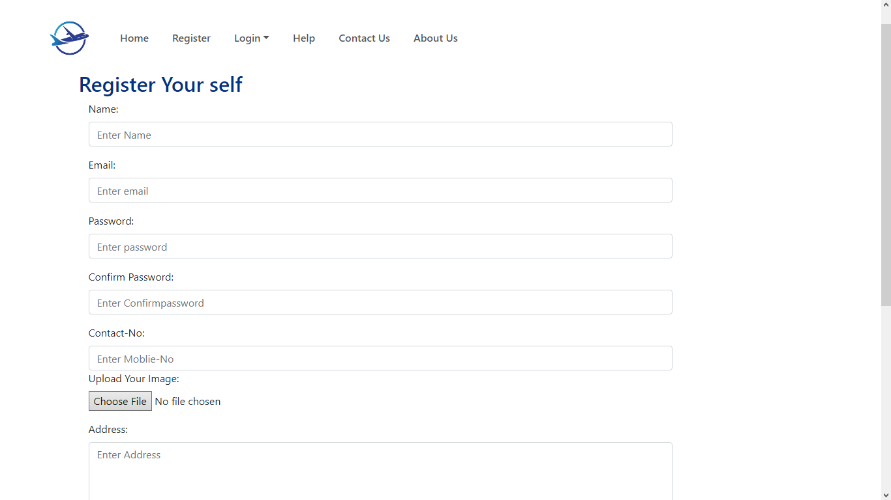

**Interface 2: User Registration Page**

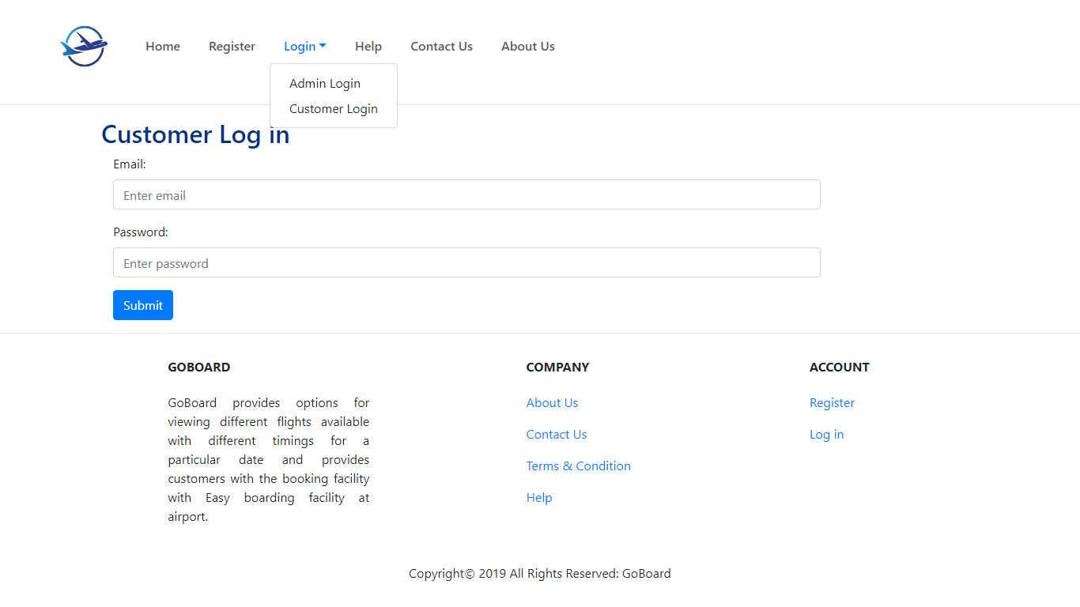

**Interface 3: Customer Log in Page**

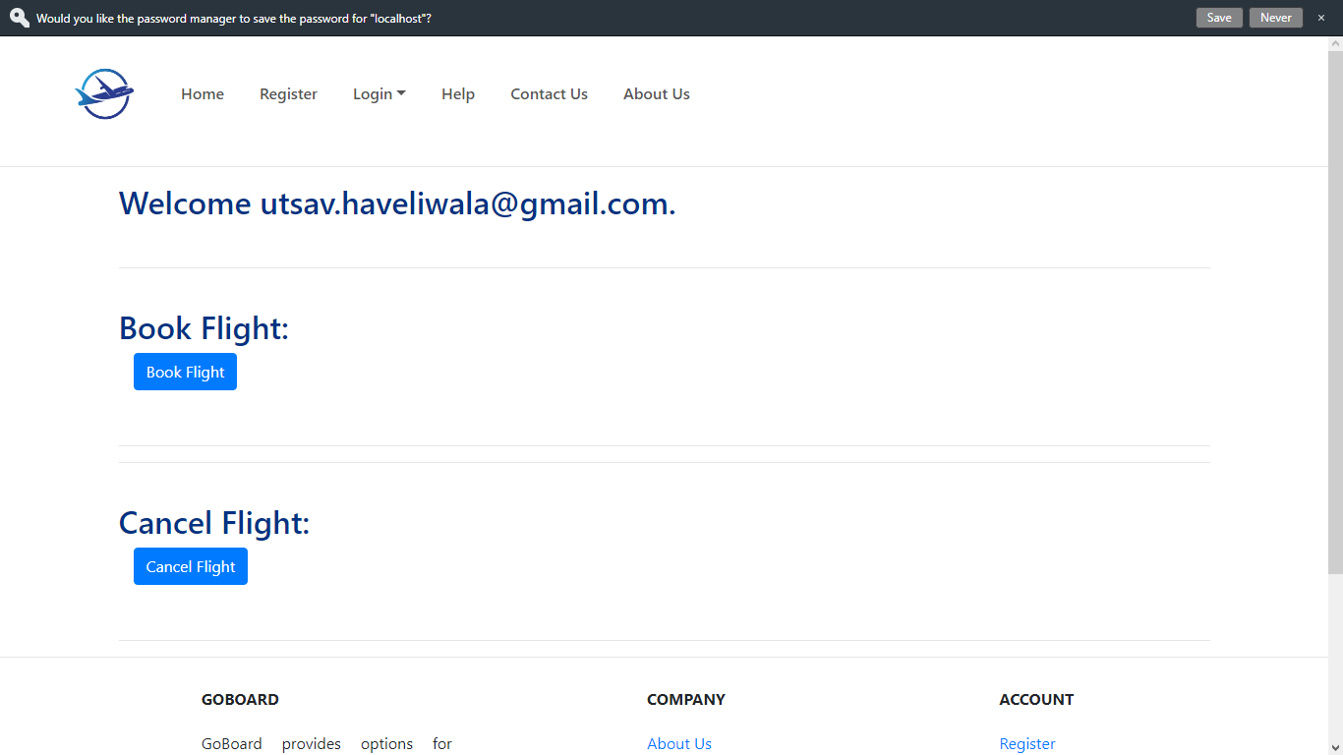

**Interface 4: User Account Page**

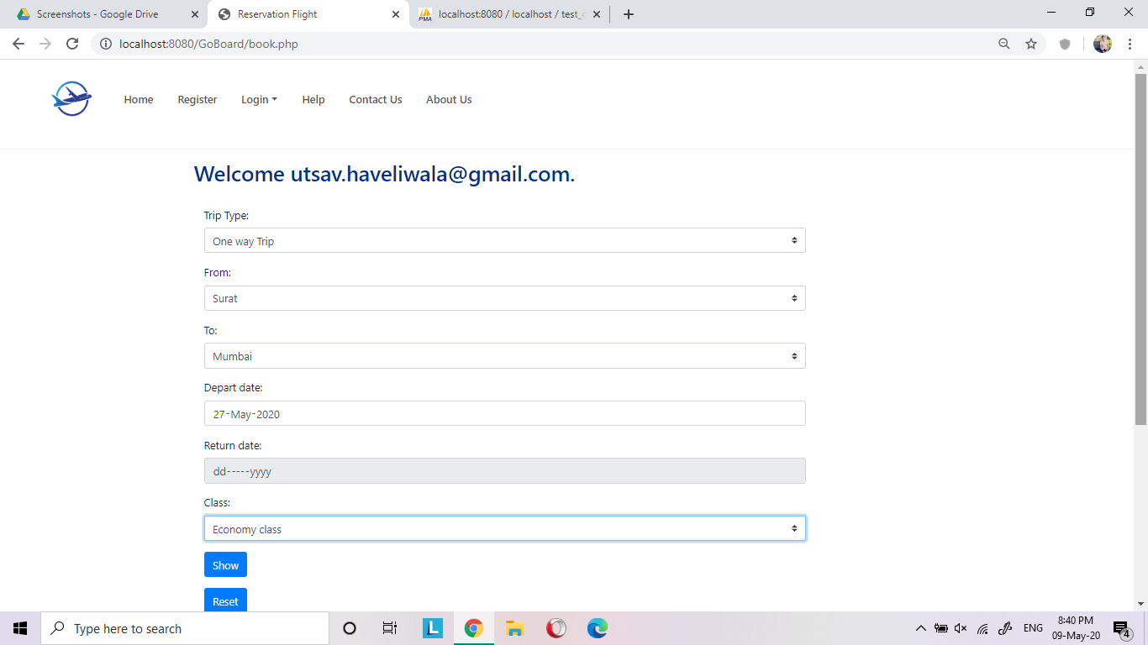

**Interface 5: Booking Page**

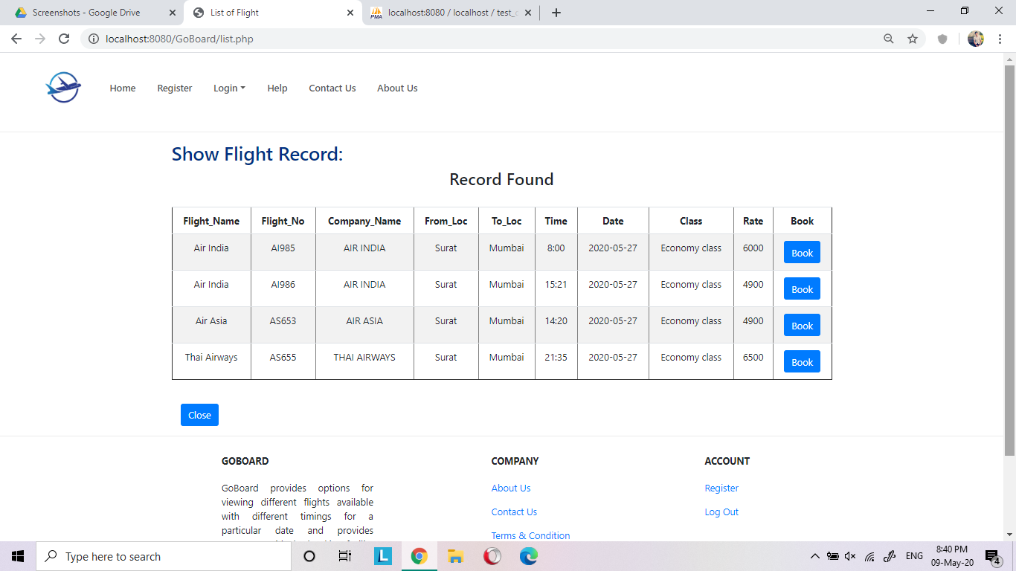

**Interface 6: Flight Information Page**

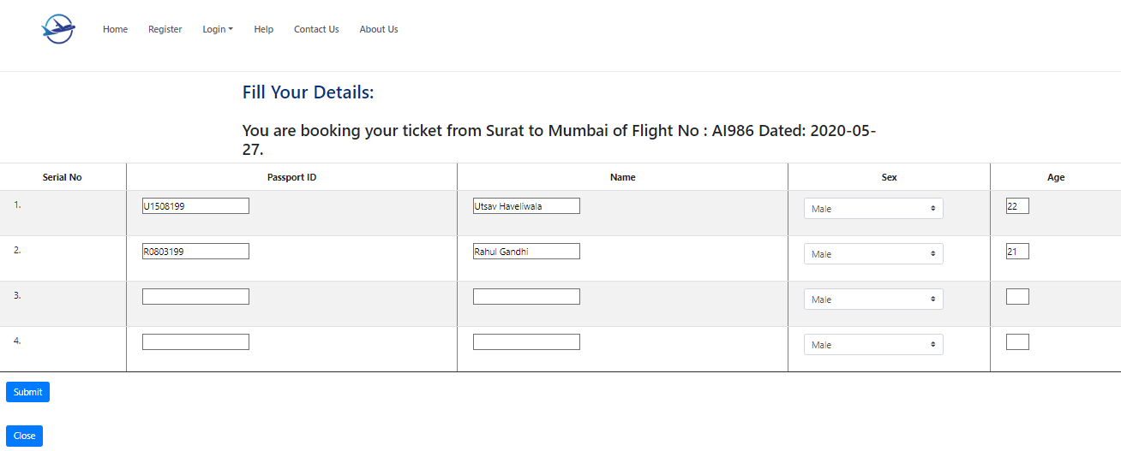

**Interface 7: Confirming Flight Ticket**

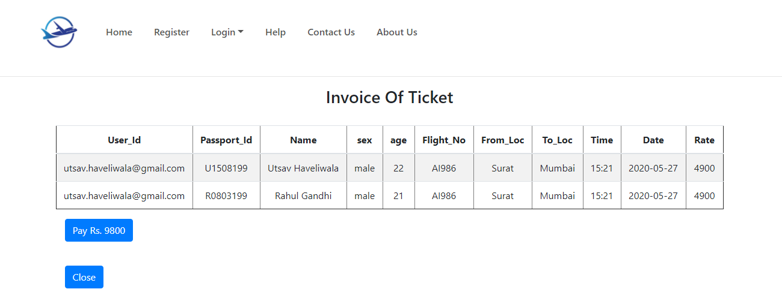

**Interface 8: Displaying Ticket**

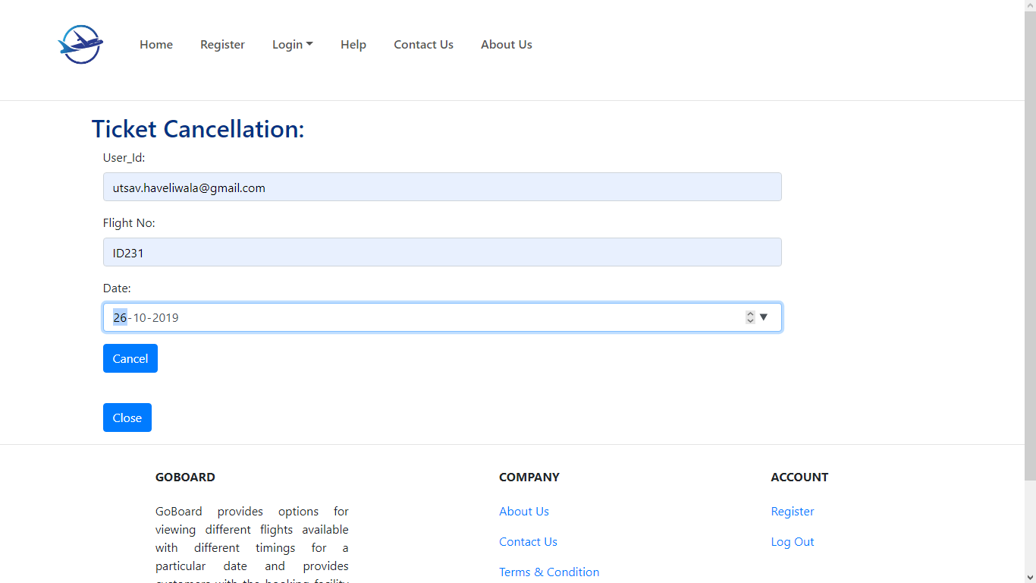

**Interface 9: Ticket Cancellation Page**

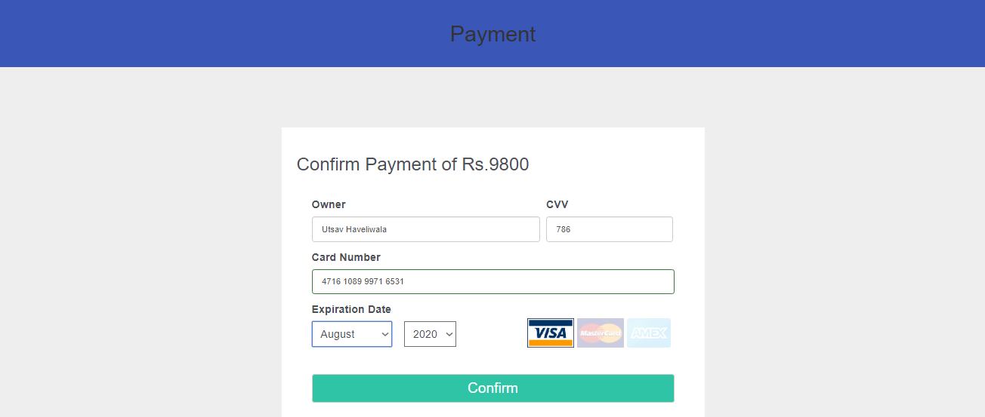

**Interface 10: Payment page**

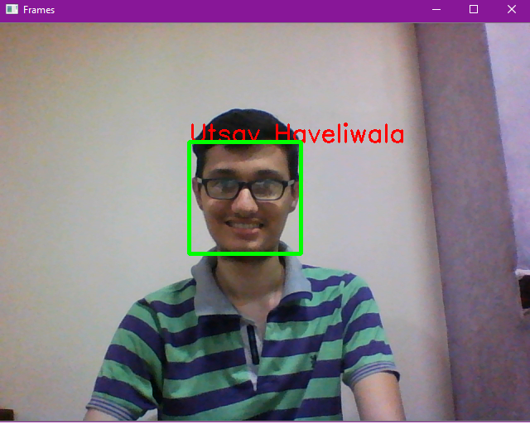

**Interface 11: Recognizing Face**

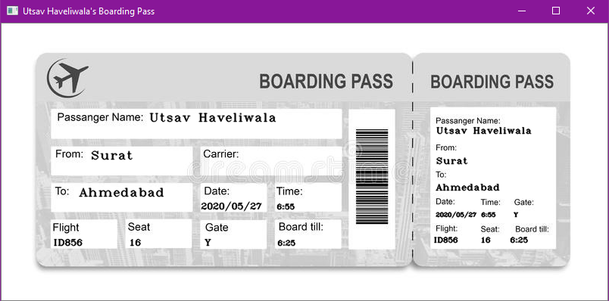

**Interface 12: Boarding Pass**

# Conclusion

To conclude, this system can be used by the passengers which allow them to board quickly rather than the old method. This system provides the protection against the forgery, because the boarding pass can be faked. This system will match the face of the passengers with the face stored in the database of the profile of the passengers.

## References

1. <https://patents.google.com/patent/US5991429A/en>
2. <https://patents.google.com/patent/US20060120571>
3. <https://patents.google.com/patent/US20140016837>
4. <https://patents.google.com/patent/US8798391>
5. <https://patents.google.com/patent/EP2680190A3>
6. <https://patents.google.com/patent/US7175528>
7. <https://patents.google.com/patent/US9639740B2/en>
8. <https://patents.google.com/patent/US5164992A/en>